# Install a Windows 10 Virtual Machine (VM)

In this lab we will create a Windows 10 Virtual Machine. It will allow us to experiment without risk of damaging the OS on our host (hardware) machine.

# Windows 10 installation CD or ISO image

When installing a new Operating System (OS) on hardware, we need to be able to boot the computer from something other than the hard drive we will put the new OS on. Usually this is a CD-ROM or a USB Flash Drive, although it can also be a network storage location. Since we are creating a VM, it is easier to use a file called an ISO image, which is a copy of the information on a DVD in the format that DVDs use, ISO-9660 (it can be used to create a DVD, although we won’t need to do that.) We have a copy of a Windows 10 ISO file on our classroom server.

## Retrieve ISO file

<https://www.microsoft.com/en-us/evalcenter/evaluate-windows-10-enterprise>

## Map a Network Drive

The operation that connects your computer’s file system to a directory (file share) on another computer is called mapping (mounting in Linux lingo.) A Windows 10 ISO is stored on our classroom fileserver so that we will not waste Internet bandwidth downloading multiple copies. Open File Explorer (the icon looks like a file folder) and right-click on This PC. Select “Map network drive…”

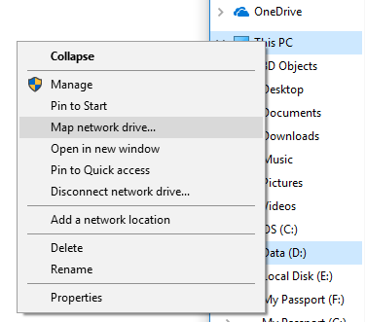 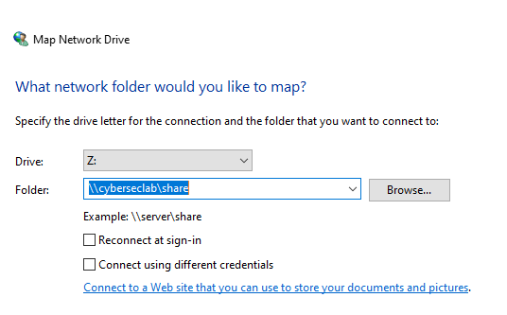

Enter \\cyberseclab\share in the Folder: box and click Finish. You should be presented with a request for credentials. The user name for our class is svgs and the password is Iwannahack! (the first character is a capital “i”, not a 1 or an L.) Then you should see a new window in file explorer showing the contents of the folder “share” on our server “cyberseclab”. The two backwards slashes (the one above the Enter key, not the one next to the period key) are Microsoft’s way of specifying a computer or network location. You have now connected to the server using Microsoft’s Server Message Block (SMB) protocol, also known as the Common Internet File System (CIFS) protocol.

## A Note on Bootable Flash Drives

We will not need a bootable flash drive here, but in the future, you may want to boot from an OS installed on a flash drive. The simplest way to make a bootable drive using Windows is to download an application called Rufus (<https://rufus.akeo.ie/>). If you do not want to take the risk of downloading an application, you can make a bootable flash drive from the Windows command line. See the “ISO Boot Disk” file in Unit 0 of Canvas, or go here: <https://betanews.com/2015/07/29/how-to-create-a-bootable-windows-10-usb-drive/>. Copying large files to a flash drive, or installing from a flash drive, will be much faster if you use USB 3.0 (blue plastic inside connector) instead of USB 2.0 (red plastic inside connector) flash drives.

# Create a new VM

Open VMware Workstation Player and select File > New Virtual Machine.  
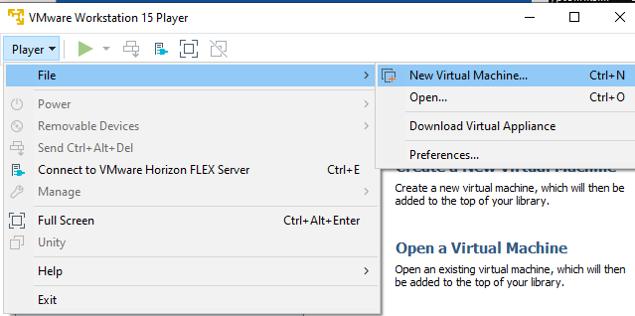

Select “I will install the operating system later.” We will install the OS manually rather than use VMware’s wizard.

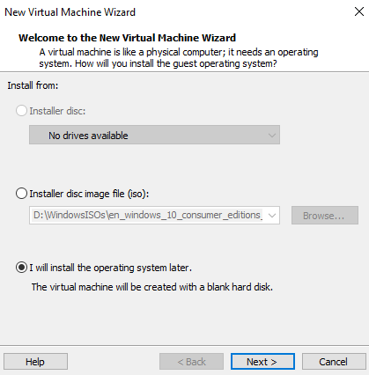

We want to tell VMware that the VM will be Windows 10 x64.  
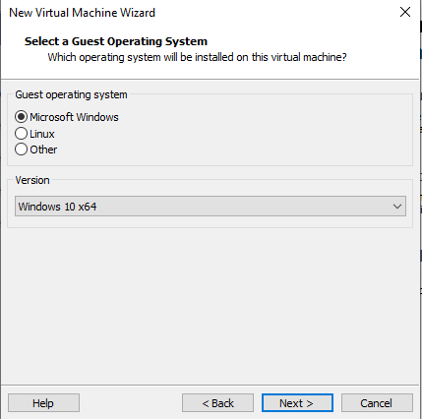

Give the VM a name and tell VMware where to save the VM’s files. By default, it creates a “Virtual Machines” directory in your My Documents folder, which is fine.  
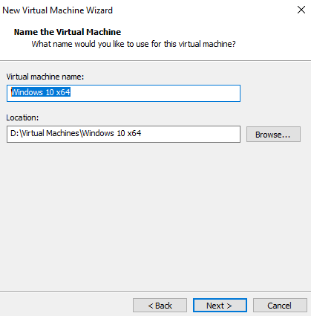

The Maximum disk size (GB) can be left at 60 unless you are short on disk space. Allow VMware to split the disk into multiple files.  
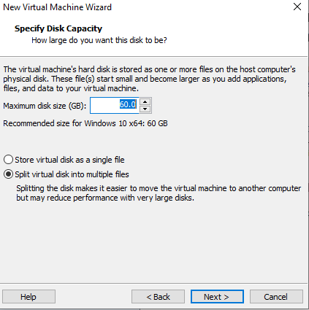

Select Customize Hardware and increase the memory for the VM to 4 GB. VMs usually run faster with more memory, as long as your host machine has enough memory. The classroom computers have 8 GB of RAM, so 4 GB should be a safe choice for the VM.  
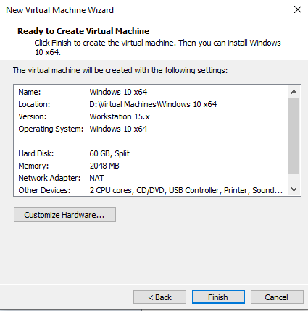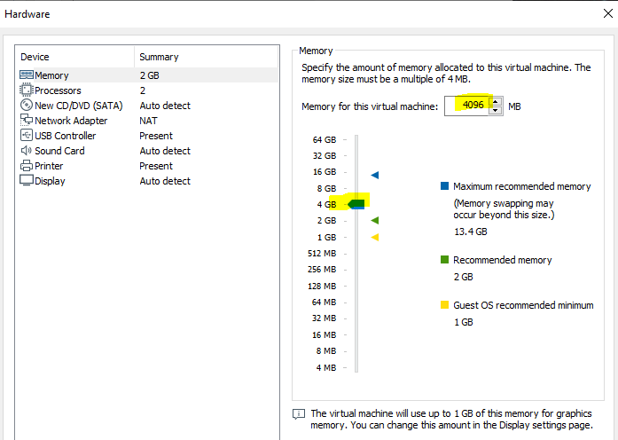

# Set the VM to boot from your ISO file

If we were installing on hardware, we would have to set the BIOS so the computer boots from our media, either the DVD or flash drive. With a VM, we need to tell the VM to boot from our ISO file. Select the VM you just created in VMware Player and choose File > Manage > Virtual Machine Settings.  
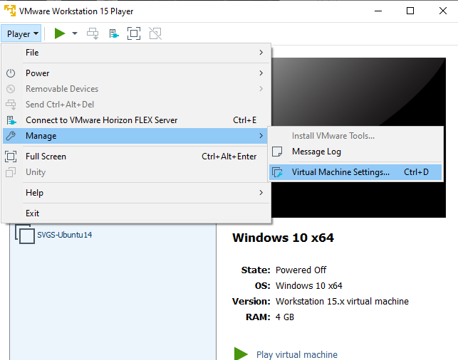

Select CD/DVD and “Use ISO image file.” Browse to the location where you stored your ISO file and select OK.  
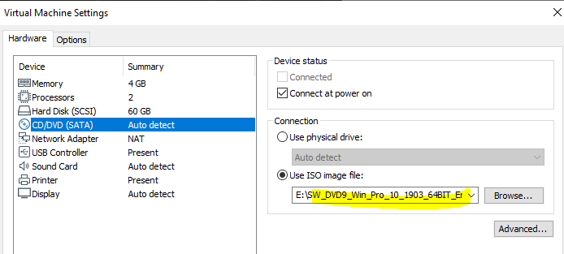

# Boot the VM from the ISO file and Install Windows 10

Select “Play Virtual Machine.” When the VM starts it should detect the ISO and boot from it. If it does, it will display “Press any key to boot from CD or DVD.” Press any key before the message disappears.   
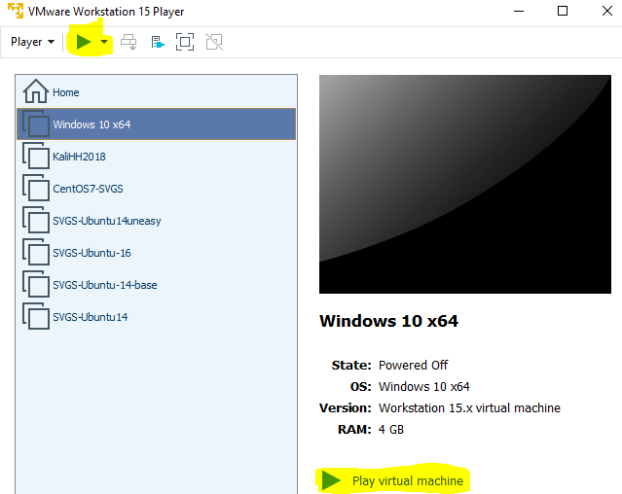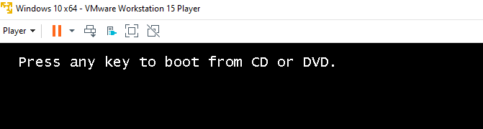

if you don’t see the any key message, make sure the CD/DVD is connected and set to the correct file.  
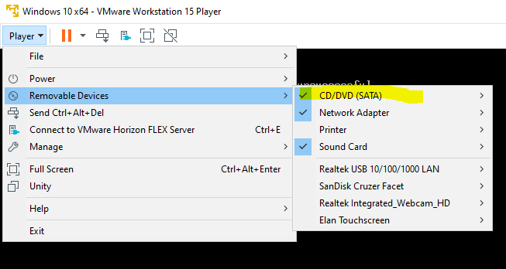

Note: The VM may steal your mouse cursor. If you find you cannot move your cursor select Control-Alt to free it. Later when VMware tools are installed on the VM, you won’t have this problem.

With luck, the computer will load a very simple installer OS from the CD and you will see this. After clicking Next, tell the program to install now.

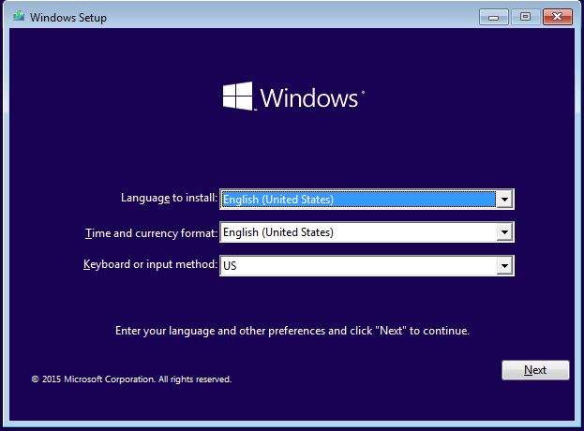 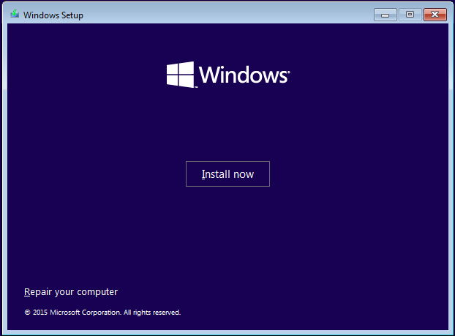

We have a license for Windows 10 Enterprise, so select that.  
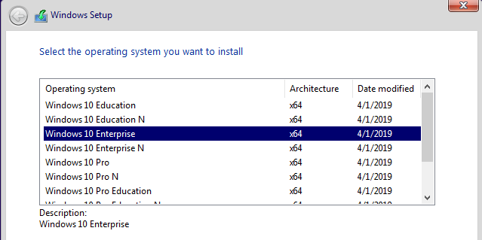

We won’t show every screen, but the next one is misleading and needs some discussion.

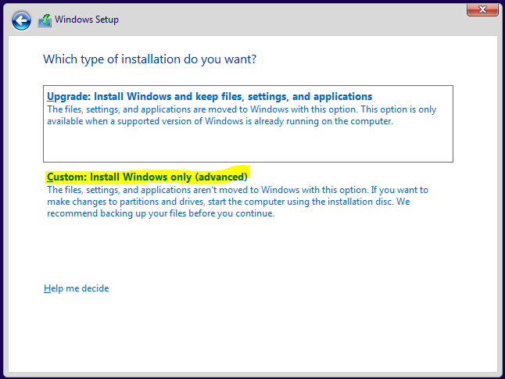

We need the option to Install Windows, not Upgrade. I assume this is “advanced” because it will overwrite the previous installation and destroy the information that is currently on the hard disk. Since our virtual hard disk is empty, that is not a problem.

# Configure Windows

When the VM boots it will try to get you to use a Microsoft online account to log in to the VM. That works, but I prefer to use an account that is local to the VM. We won’t be joining the VM to a Windows Domain this time, but it is the only choice that winds up where we want to be. (An Active Directory Domain is the method that Windows uses to control large numbers of computers at once, offering things like central login. SVGS computers are in a domain, which is why you can log in to any SVGS computer with the same username and password.) Select “Domain join instead.”

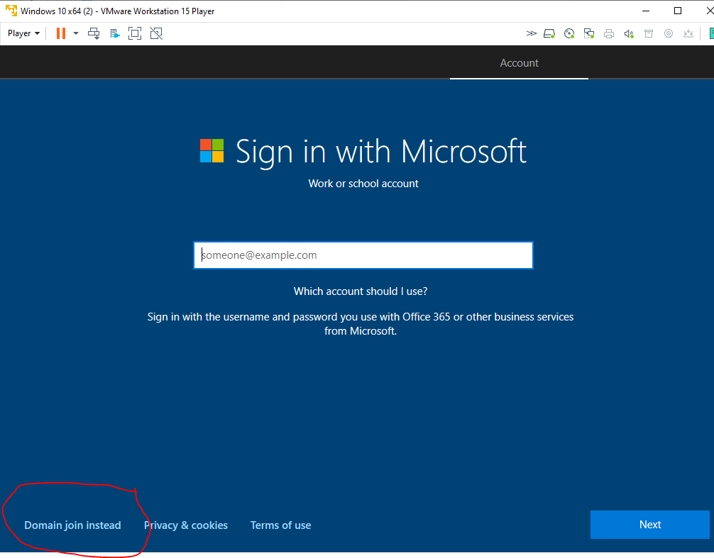

Microsoft tries to force us to use an account on their system to log in to the computer. Instead, select “Skip this step.”

Create your account. The username can be whatever you want, within reason. Keep in mind that faculty or your parents may see your username, so it’s best to pick something that is not embarrassing. Make sure you can remember it.  
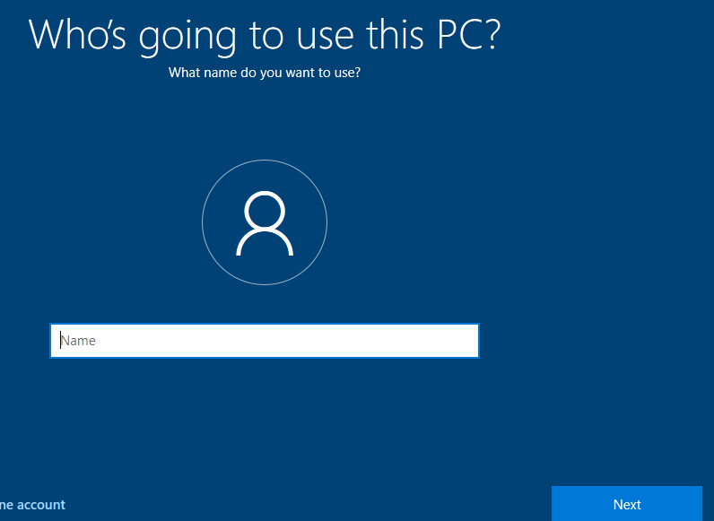

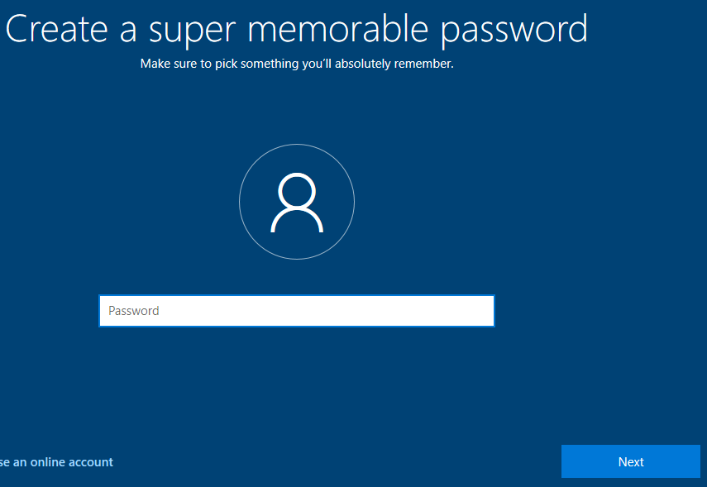

# Activate (License) Windows

Open the settings panel. It should have a message at the bottom saying you need to activate Windows.

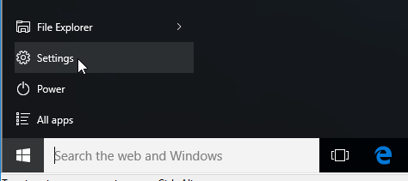 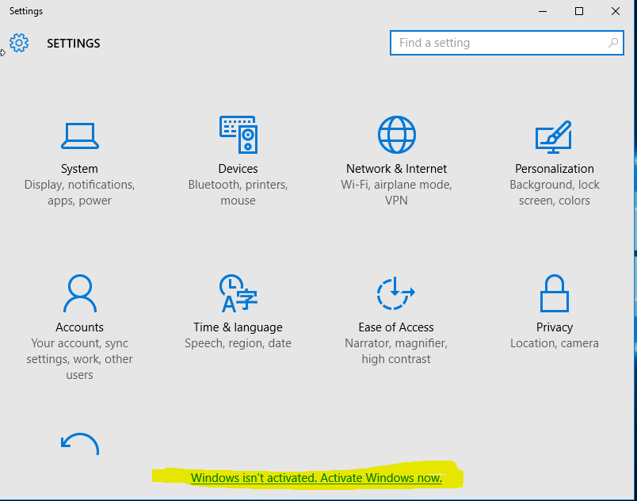

Select “Change product key” and enter the key your instructor gives you. This key belongs to SVGS, so **do not** copy it for your personal use. We will have other keys provided to us by Cyber Patriots that we can use for personal copies.

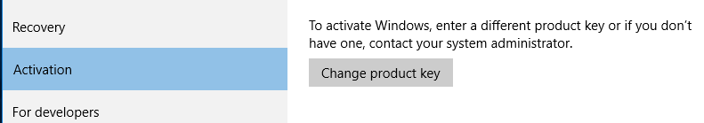

# Update your VM

Most vendors, including Microsoft, provide software updates on a monthly or as needed basis. Sometimes these updates, or patches, fix serious remote code execution vulnerabilities. It is often difficult to tell which patches must be installed immediately, so it is best to install all patches regularlly. There is a small risk in installing patches, as sometimes they break things. Large companies often test new patches for a few days before installing them. Some users wait a few days and watch their Internet feeds for reports of problems, but don’t wait long!

Select settings, then Updates and Security (at the bottom.)  
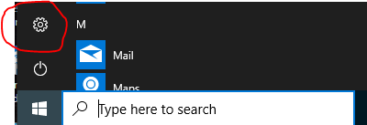 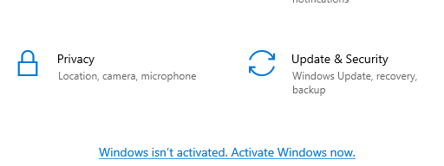

Click “Check for Updates” and install any outstanding updates.  
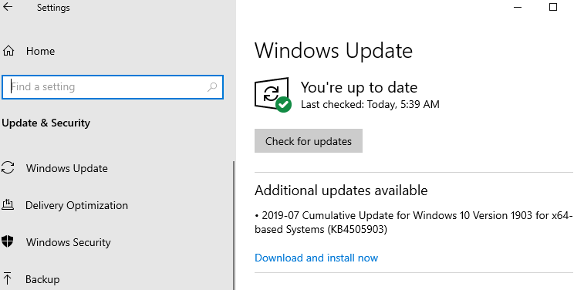

# **HAND IN**

1. One version of the SMB protocol we used when we copied the ISO file from the classroom server has vulnerabilities that resulted in some famous exploits over the last year or two. Search Google (smb vulnerability may be helpful,) and then write a sentence or two about what you find.